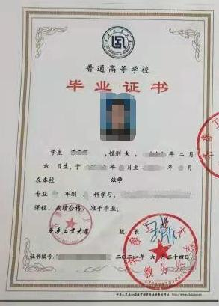

Qilu University of Technology
DIPLOMA

This is to certify that WANG Wei, female, born on March 12, 1992, has studied in the Department of Printing and Packaging Engineering, Qilu University of Technology with a specialty of Printing Engineering from September 2010 to June 2013. Upon completing and passing all the required courses of the 4-year undergraduate program, she/he is granted graduation.

CHEN Jiachuan
President of
Qilu University of Technology

Certificate No.: 10431xxxxxxxxxxxxx Date: June 27, 2013

Note: The certificate is equivalent to the one issued to students in Chinese.

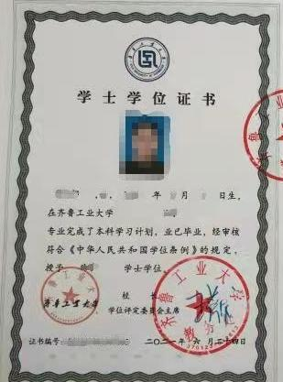

Qilu University of Technology
BACHELOR DEGREE CERTIFICATE

This is to certify that WANG Wei, female, born on March 12, 1992, majoring in Printing Engineering, has completed the courses required for the bachelor’s degree with satisfactory graded and succeeded in dissertation defense. In accordance with the Regulations on Academic Degree of the People’s Republic of China, she/he is awarded the degree of the Bachelor of Engineering.

CHEN Jiachuan
Chairman of
Degree Appraising Committee of
Qilu University of Technology

Bachelor Degree Certificate No.: 10431xxxxxxxxxxx Date: June 27, 2013

Note: The certificate is equivalent to the one issued to students in Chinese.

